Joshua Renier Van Rooyen

  ST10153536

User manual

**Video Link:**[**https://advtechonline-my.sharepoint.com/:v:/g/personal/st10153536_vcconnect_edu_za/ETGXfUw6-_JCobSXaR0AhWAB2mHgeyXfDGVdcdXgiTATsw?e=gAORxP&nav=eyJyZWZlcnJhbEluZm8iOnsicmVmZXJyYWxBcHAiOiJTdHJlYW1XZWJBcHAiLCJyZWZlcnJhbFZpZXciOiJTaGFyZURpYWxvZy1MaW5rIiwicmVmZXJyYWxBcHBQbGF0Zm9ybSI6IldlYiIsInJlZmVycmFsTW9kZSI6InZpZXcifX0%3D**](https://advtechonline-my.sharepoint.com/:v:/g/personal/st10153536_vcconnect_edu_za/ETGXfUw6-_JCobSXaR0AhWAB2mHgeyXfDGVdcdXgiTATsw?e=gAORxP&nav=eyJyZWZlcnJhbEluZm8iOnsicmVmZXJyYWxBcHAiOiJTdHJlYW1XZWJBcHAiLCJyZWZlcnJhbFZpZXciOiJTaGFyZURpYWxvZy1MaW5rIiwicmVmZXJyYWxBcHBQbGF0Zm9ybSI6IldlYiIsInJlZmVycmFsTW9kZSI6InZpZXcifX0%3D)

**LIVE WEBSITE LINK:**

[**https://prog6212poest10153536.azurewebsites.net/**](https://prog6212poest10153536.azurewebsites.net/)

**Register**

User can register with their username and password.

**Login**

Details used to register is used to login

**Modules Page**

When a user creates their new account, a blank module is created. It is advisable to delete this module and create a new one.

**Add Module**

The Add Module button navigates you to this Add Module page where you can add a module.

Once the module has been created, it will display like this.

**Edit Module**

In order to update the Hours Spent, you must select the “Edit Button” to navigate to the Edit page and you can manually input the Hours Spent.

**Delete Module**

Just click on the delete button for any module card and that specific module will be deleted.

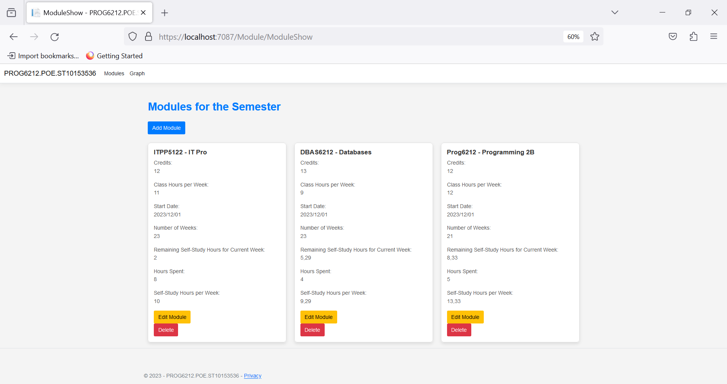

**Graph**

This graph takes the Hours Spent, Current Week Self Study Hours Remaining and Self-Study Hours for you to keep track of your progress for each module.

